Title: Upon a Summers Day
Dance #: 1

Shape: Line
Type: Standard
# Dancers: 3 couples

Time signature: 6/8
A part: 8 measures, 16 dance beats
B part: 8 measures, 16 dance beats

Facsimile:

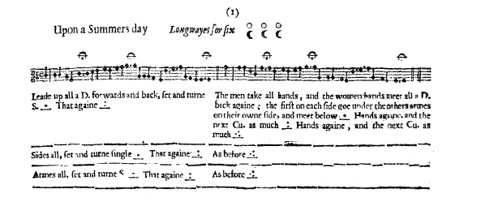

Transcription:

Upon a Summers Day Longways for six

A1: Leade up all a D. forwards and back. set and turne S. _._ That agine _:_

B: The men take all hands, and the women hands meet all a D. back again; the first on each side goe under the others arches on their owne side, and meet below _._ Hands againe, and the next CU. as much _:_ Hands againe, and the next CU. As much _.:_

A2: Sides all, set and turne single _._ Thay againe _:_

B: As before_.:_

A3: Armes all, set and turne single _._ Thay againe _:_

B: As before_.:_

Redaction:

A1: L double forward, R double back
Set left, set right, turn
Repeat
A2: Side R, set and turn
Side L, set and turn
A3: Arm R, set and turn
Arm L, set and turn

B: Men take hands along their line,
Women take hands along their line
Lines L double back and arch arms;
Man 1 and Woman 1 move down their own line and between #2 and #3 of their own sex to fall into position C;
Couple 2 does the same
Couple 3 does the same
(all couples are now back to place)
Justification:

We agree with the current reconstruction used in Calontir.

Notes:
Check music
Assumptions: men on left of women (justification: swords, pictures, current standard practice)
Assumptions: start on left foot (justification: current standard practice)

