Title: Night Peece
Dance #: 3

Shape: Line
Type: Standard
# Dancers: 3 couples

Time signature: 6/8
A part: 4 measures, 8 dance beats
B part: 12 measures, 24 dance beats

Facsimile:

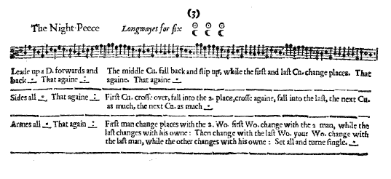

Transcription:

The Night Peece Longways for six

A1: Leade up a D. forwards and back _._ That againe _:__

B1: The middle Cu. fall back and slip up, while the first and last Cu. change places. That again. That again. _._

A2: Sides all _._ That again _:_

B2: First Cu. cross over, fall into the 2. place, cross again, fall into the last, the next Cu. as much, the next Cu. as much _._

A3: Armes all _._ That again _:_

B3: First man change places with th 2. Wo. first Wo. change with the 2. man, while the last changes with his owne: Then change with the last Wo. your Wo. change with the last man, while the other changes with his owne: Set all and turne single _._

Redaction:

A1: L double forward, R double back
Repeat
(pivot to face partner at end of A1)

B1: Shuttlecocks for 3 –
Couple 1 move down the line between Couple 2 and to the outside of Couple 3 as Couple 2 and Couple 3 move up the set;
Repeat with Couple 2;
Repeat with Couple 3

A2: Side R, Side L

B2: Couple 1 cross to partners place, cast behind couple 2, cross again between couple 2 and couple 3, and move into position C as Couple 2 and Couple 3 move up the set
Repeat with Couple 2;
Repeat with Couple 3

A3: Arm R, Arm L

B3: Man 1 and Woman 2 switch places
Woman 1 and Man 2 switch places
Man 3 switch with Woman 3
Man 1 (in position B) and Woman 3 switch places
Woman 1 (in position B) and Man 3 switch places
Man 2 (in position A) switch with Woman 2 (in position A)
Set and Turn

Justification:

Each couple should take 4 measures to move down the line; at the end of 12 measures everyone is back to position

Justify between vs around C3&C1

Side = L double forward to partner, R shoulder to right shoulder (per Del’s Dance Book and standard SCA practice)

Switches should be done as slips into the new position with the individuals facing each other (ie. Picking of Sticks) allowing for interaction/flirting and ease of movement.

Notes:
We like the idea of doing this dance 3x through since the dance will end C2, C3, C1 and going 3x through the entire dance will reset the lead couple to position A.

Assumptions: men on left of women (justification: swords, pictures, current standard practice)
Assumptions: start on left foot (justification: current standard practice)

