Title: Boatman
Dance #: 4

Shape: Line
Type: Standard
# Dancers: 3 couples

Time signature: 6/8
A part: 8 measures, 16 dance beats
B part: 8 measures, 16 dance beats

Facsimile:

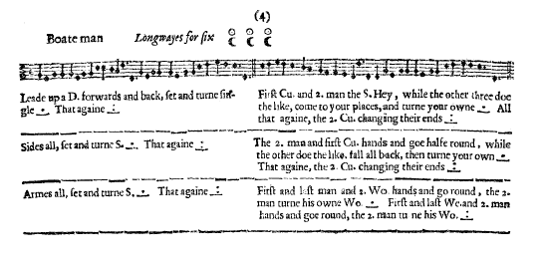

Transcription:

Boate man Longways for six

A1: Lead up a D. forwards and back, set and turn single _._ That againe _:_

B1: First Cu. and 2. man the S. Hey, while the other three doe the like, come to your places, and turne your owne _._ All that againe, the 2. Cu. changeing their ends _:_

A2: Sides all, set and turne single _._ That againe _:_

B2: The 2. man and the first Cu. hands and goe halfe round, while the other doe the like. fall all back, then turn your owne _._ That again, the 2. Cu. changing their ends _:_

A3: Armes all, set and turne single _._ Thay againe _:_

B3: First and last man and 2. Wo. hands and go around, the 2. man turn his own Wo. _._ First and last Wo. and 2. man hands and goe round, the 2. man turn his Wo. _:_

Redaction:

A1: L double forward, R double back
Set left, set right, turn
Repeat

B1: Man 2 with Couple 1 do half-a-hey as Woman 2 with Couple 3 do half- a-hey; all half turn with your partner
(everyone should be back to position)
Repeat with M2 going down the hall to Couple 3 and Woman 2 going up the hall to Couple 1

A2: Side R, set and turn
Side L, set and turn

B2: Man 2 with Couple 1 does a half circle as Woman 2 with Couple 3 does a half circle
Man 2 and Woman 2 pass between Couple 1 and 3 respectively and into place; all half turn with your partner
(everyone should be back to position)
Repeat with M2 going down the hall to Couple 3 and Woman 2 going up the hall to Couple 1

A3: Arm R, set and turn
Arm L, set and turn

B3: Man 1, Man 3 and Woman 2 do a full circle around Man 2
Couple 2 do a full turn
Woman 1, Woman 3 and Man 2 do a full circle around Woman 2
Couple 2 do a full turn

Justification:

Men go up the hall, women go down the hall, start with R shoulder to the opposite gender

Women go up the hall, men go down the hall, start with R shoulder to the opposite gender

Ends with Man 2 and Woman 2 at the top and bottom of the set

This can be done by pulling the active couple through or by arching (london bridge?)

Man 2 stands in the center of the circle, circle should take 2 measures to complete
Couple 2 have 2 measures to do this turn

Notes:
Assumptions: men on left of women (justification: swords, pictures, current standard practice)
Assumptions: start on left foot (justification: current standard practice)

