Title: Blew Cap
Dance #: 2

Shape: Line
Type: Standard
# Dancers: 3 couples

Time signature: 6/8
A part: 8 measures, 16 dance beats
B part: 8 measures, 16 dance beats

Facsimile:

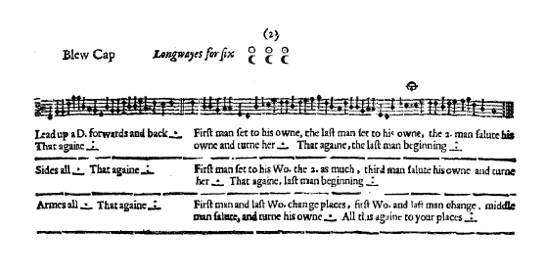

Transcription:

Blew Cap Longways for six

A1: Lead up a D. forwards and back _._ That again _:_

B1: First man set to his owne, the last man set to his owne, the 2. man salute his own and turn her _._ That again, the last man beginning _:_

A2: Sides all _._ That again _:_

B2: First man set to his Wo. the 2. as much, third maan salute his owne and turn her _.__ That againe, last man beginning _:_

A3: Armes all _._ That again _:_

B3: First man and last Wo. change places, first Wo. and the last man change, middle man salute, and turne his owne _._ All this again to your places _:_

Redaction:

A1: L double forward, R double back
Repeat
(pivot to face partner at end of A1)

B1: Man 1 set L,R
Man 3 set L,R
Man 2 honor and full turn with partner
Man 3 set L,R
Man 1 set L,R
Man 2 honor and full turn with partner

A2: Side R, Side L

B2: Man 1 set L,R
Man 2 set L,R
Man 3 quick! honor and full turn with partner
Man 3 set L,R
Man 2 set L,R
Man 1 honor and full turn with partner

A3: Arm R, Arm L

B3: Man 1 and Woman 3 switch places
Woman 1 and Man 3 switch places
Man 2 honor and full turn with partner
Man 3 and Woman 1 switch places
Woman 3 and Man 1 switch places
Man 2 honor and full turn with partner

Justification:

Set L,R = single left, single right - per Playford’s instructions for set and turn

The honor should be a 1 count bow or acknowledgement of partner, leaving 7 counts to complete the full turn

Side = L double forward to partner, R shoulder to right shoulder (per Del’s Dance Book and standard SCA practice)

Switches should be done as slips into the new position with the individuals facing each other (ie. Picking of Sticks) allowing for interaction/flirting and ease of movement.

The second half of B3 begins with Man 3 per continuity with B1 and B2

Notes:
We have assumed that the repeat sign in the A part music is repetitive with the “_._ “ and likewise the repeat sign in the B part is repetitive with the strain played x number of times symbols.

Assumptions: men on left of women (justification: swords, pictures, current standard practice)
Assumptions: start on left foot (justification: current standard practice)

Compare vs Dels version

