Title: Woodicocke Shape: Line
Dance #: 15 Type: Standard
# Dancers: 6

Time Signature: 6/8
A Part: 4 measures, 8 beats, 2 times?
B part: 4 measures, 8 beats, 2 times?
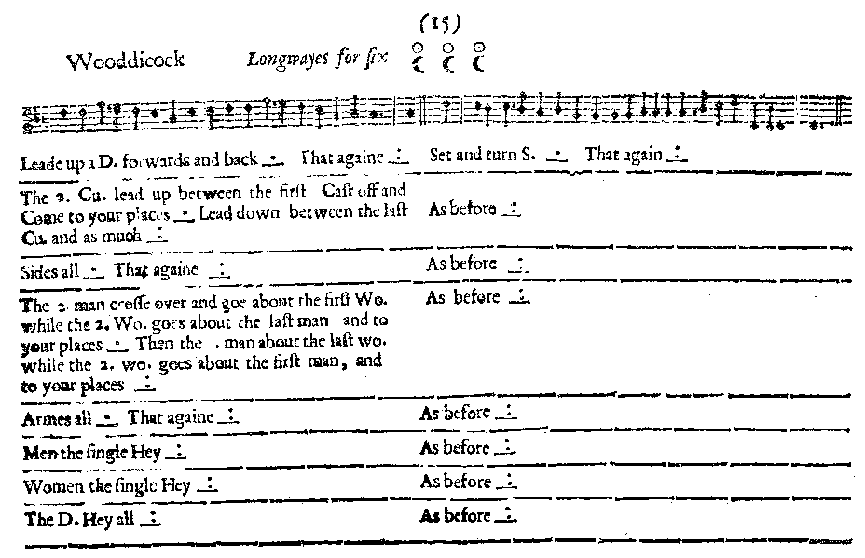
Facsimile:

Transcription:

Leade up a D. forwards and back _.__ That againe _:__ Set and Turn S. _.__ That againe _:__

The 2. Cu. lead up between the first Cast off and come to your places _.__ Leade down between the last Cu/ and as much _:__ As before _:__

Sides all _.__ That againe _:__ As before _:__

The 2. man cross over and goe about the first Wo. while the 2. Wo goes about the last man and to your places _.__ The 2. man about the last wo. while the 2. Wo goes about the first man and to your places _:__ As before _:__

Armes all _.__ That againe _:__ As before _:__

Men the single Hey _:: As before _:__

Women the single Hey _:: As before _:__

The D. Hey all _:__ As before _:__

Redaction:

A1: Double forward and back. Repeat.
B1: Set and turn. Repeat

A2: Couple 2 go up through Couple 1, cast off and back to place
Couple 2 go down through Couple 3, cast off and back to place
B2: Set and turn. Repeat

A3: Side left. Side right
B3: Set and turn. Repeat

A4: C2 cross over, M2 go around W1 while W2 go around M3 and back to place.
C2 cross over, M2 go around W3 while W2 go around M1 and back to place.
B4: Set and turn. Repeat

A5: Arm right, Arm left
B5: Set and turn. Repeat

A6: Men do full hey
Women do full hey
B6: Set and turn. Repeat

A7: Double hey
B7 Set and turn. Repeat
Justification and Notes:

(Double hey = grand rights and lefts)

