Title: Wherligig Shape: Line
Dance #: 11 Type: Standard
# Dancers: 6

Time Signature: 6/8
A Part: 4 measures
B Part: 8 measures

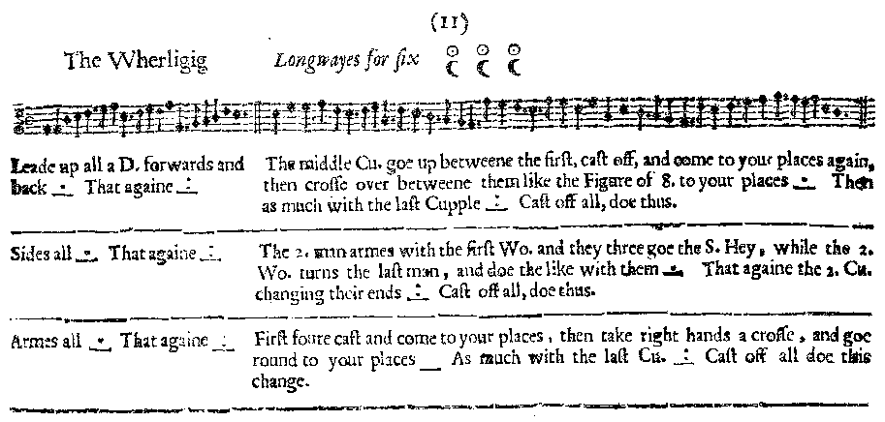
Facsimile:

Transcription:

Lead up a D. forwards and back _.__ That again _:__

The middle Cu. goe up between the first, cast off and come to your places again, then cross over between them like the figure of 8, to your places _.__ Then as much with the last Cupple _:__ Cast off all, doe thus.
________________________________________
Sides all _.__ That againe _:__

The 2. man armes with the First Wo. and they three goe the S. Hey, while the 2. Wo. turns the last man, and doe the like with them _.__ That again the 2. Cu. changeing their ends _:__ Cast off all, doe thus.
________________________________________
Armes all _.__ That againe _:__

First foure cast and come to your places, then take right hands a cross, and goe round to your places ___ As much with the last Cu. _:__ cast off all doe this change.

Redaction:

Justification and Notes:

