Title: Stingo, Or the Oyle of Barly Shape: Line
Dance #: 10 Type: Standard
# Dancers: 6

Time Signature: 6/8
A Part: 4 measures, 8 beats, 2 times
B Part: 8 measures, 16 beats, 2 times

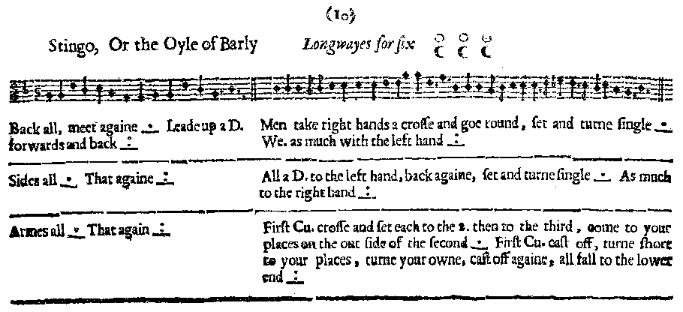
Facsimile:

Transcription:

Back all meet again _.__ Lead up a D. forwards and back _:__
Men take right hands a crosse and goe round, set and turn single _.__ We. as much with the left hand _:__

Sides all _.__ That againe _:__
All a D. to the left hand, back againe, set and turn single _.__ As much to the right hand _:__

Armes all _.__ That againe _:__
First Cu. cross and set each to the 2. then to the third, come to your places on the out side of the second _.__ First Cu. cast off, turn short to your places, turn your owne, cast off againe, all fall to the lower end _:__

Redaction:

A1: Double back away, and forward to meet.
Lead up a double forward and back.
B1: Men right-hand star, set and turn
Women left-hand star, set and turn

A2: Side right. Side left.
B2: (Face own left) Double forward and back. (face partner) Set and turn
(Face own right) Double forward and back. (face partner) Set and turn

A3: Arm right. Arm left
B3: C1 cross and come inside to face your opposite in C2. C1 set to C2, C1 set to C3.
Cast out the bottom of the set and return to your partner’s place.

REST OF DANCE UNCERTAIN.

C1 cast off “somewhere”
Full turn all
Cast off to reverse the line?
Justification and Notes:

Note: Lines start facing!
(Turn to face up before doubling forward)

Unclear whether C1 comes between C2 and then moves to C3 to set with them, or whether M1 crosses to between W2 and W3, sets to W2, then turns to set to W3 (W1 doing the same).
Also unclear whether cast is from the bottom of the set, or whether C1 steps out around C2, into partner’s place, and then cross to own place.

Unsure what “turn short to your places” means. If C1 is just turning, why doesn’t it say “full turn”? One possibility is that a full turn will send both of them over their left shoulder, whereas a cast and turn short will send them over opposite shoulders.
Also unsure what “all fall to the lower end” means: reverse the line?

