Title: Saraband Shape: line
Dance #: 17 Type: New Progression
# Dancers:

Time Signature: 6/8
A Part: 8 measures, 32 beats, 1 time
B Part: Same music as A part

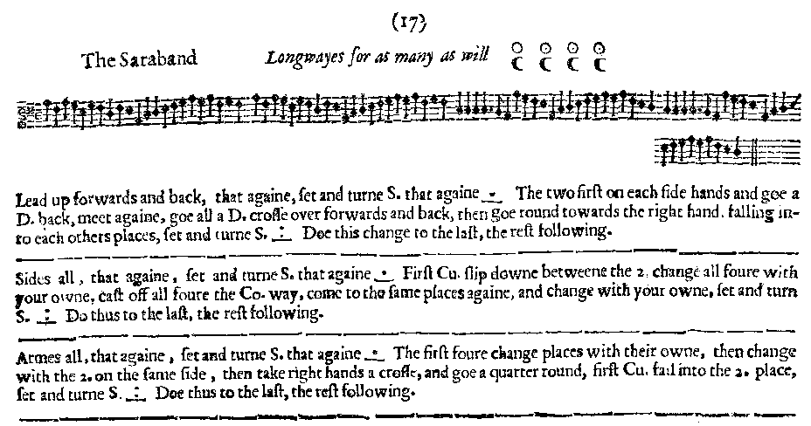
Facsimile:

Transcription:

Lead up forwards and back, that againe, set and turne S. that again _.__
The two first on each side hands and goe a D. back, meet again, goe all a D. cross over forwards and back, then goe round towards the right hand, falling into each others places, set and turn S. _:__ Doe this change to the last,
the rest following.

Sides all, that againe, set and turne S. that again _.__
First Cu. slip downe between the 2. change all foure with your owne cast off all foure the Co. way, come to the same places againe, and change with your owne, set and turn S. _:__ Do thus to the last the rest following

Armes all, that againe, set and turne S. that again _.__
The first four change places with their owne, then change with eth 2. on the same side , then take right hands a crosse, and goe round, first Cu. fall into the 2. place, set and turn S. _:__ Doe thus to the last, the rest following.

Redaction:

A1: Double forward and back, Set and turn
Repeat
B1: C1 and C2 face each other, double back, double forward; double forward again to change places, double back to partner’s place. Turn same sex for 4 to switch places.
Set and turn.
C1 repeat part B1 with the next couple until C1 is at the bottom of the set. Then C2 do and repeat until line is reset.

A2: Side left, Set and turn
Side right, set and turn.
B2: C1 slip between C2 to change places. Half turn with partner. Cast off, couple 1 leading, and back to your new place. Half turn partner.
Set and turn.
C1 repeat part B2 with the next couple until C1 is at the bottom of the set. Then C2 do and repeat until line is reset.

A3: Arm right, set and turn
Arm left set and turn.
B3: C1 and C2 switch with partner, switch with same sex.
????????????????????????
Set and turn
C1 repeat part B3 with the next couple until C1 is at the bottom of the set. Then C2 do and repeat until line is reset.
Justification and Notes:

M1 & M2 take hands, W1 and W2 take hands

OR: C2 could start their progression as soon as C1 is clear.

These half turns are unclear in the MS. Could be slips, turns, gypsies, or a simple switch.

Again switch could be anything.

This portion is confusing. The instructions are those for a right-hand star with C1 falling into C2’s place. But C1 can’t do this because the sexes are on the wrong sides. It’s possible that it means to do a turn and a half with your partner, but there are 16 counts in which to do this.

