Title: Picking of Sticks Shape: Line
Dance #: 12 Type: Standard
# Dancers: 6

Time Signature: 6/8
A Part: ??

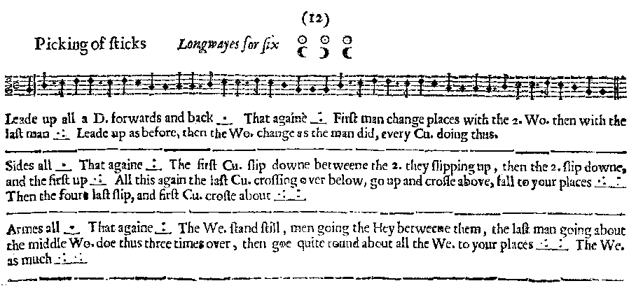
Facsimile:

Transcription:

Leade up all a D. Forwards and back _.__ That again _:__ First man changes with the 2. Wo. then with the last man _.:___ Leade up as before, then the Wo. change as the man did, every Cu. doing thus.
________________________________________
Sides all _.__ That again _:__ The first Cu. slip down betweene the 2. they slipping up, then th 2. slip
downe, and the first slip up _.:___ All this again the last Cu. crossing over below, go up and cross above, fall to your places _.:___ _:__ Then the foure last slip, and the first Cu. cross about _.:___ _:__
________________________________________
Armes all _.__ That again _:__ The We. stand still, men going the Hey between them, the last man going about the middle Wo. doe thus three times over, then goe quite round about all the We. to your places _.:_ _:_ The We. doe as much_.:_ _.:_

Redaction:

Justification and Notes:

