Title: Parsons Farewell Shape: Square
Dance #: 6 Type:
# Dancers: 2 Couples
Time Signature: 4/4
A Part: 4 measuers, 16 beats
B Part: 8 measuers, 32 beats

Facsimile:
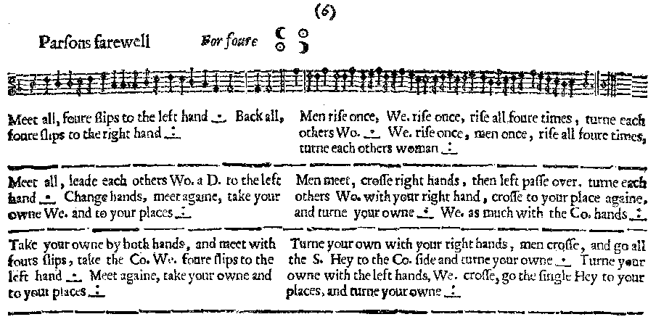
Transcription:

Parsons Farewell For Four

A1: Meet all, four slips to the left hand _.__ Back all, four slips to the right hand _:__

B1: Men rise once, Wo. rise once, rise all foure times, turn each others Wo. _.__ We. rise once, men once, rise all foure times, turn each others women _:__

A2: Meet all, leade each others Wo. a D. to the left hand _.__ Change hands, meet again, take your own We. and to your places _:__

B2 Men meet, cross right hands, then left pass over. turn each others Wo. with your right hand, cross to you place againe, and turn your own _.__ We. as much with the Co. hands _:__

A3: Take your own by both hands, and meet with four slips, the the Co. We four slips to the left hand _.__ Meet again, take your own and to your places _:__

B3: Turn your own with your right hands, men cross, and go all the S. Hey to the Co. side and turne your owne _.__ Turn your owne with the left hands, We. cross, go the single Hey to your places, and turn your owne _:__

Redaction:

A1: (face partners)
Double forward to meet, Slip to own left
Double backwards, Slip to own right (back to places)

B1: Men rise (movimento), Women rise, All rise four times.
Full turn with your corner
Repeat all.

A2: Double forward to meet.
Lead corner out, lead corner back.
Lead partner out, lead partner back
Double back to place

B2: Men take right hands, then left hands, then 1/2 turn to change places.
Full turn with corner with right hands
Men take left hands, then right hands, then 1/2 turn to change places.
Full turn corner with left hand.

A3: Take partner by both hands, slip 4 times into the set.
Take corner by both hands and slip 4 times away from the set.
Slip back into set, take partner and slip back to place.

B3: Full turn partner with right hands.
Half a hey for four on the diagonal to switch places with opposite couple (men start).
Full turn partner (with right hands?).
Full turn partner with left hands.
Half a hey for four on the diagonal to switch places with opposite couple (women start).
Full turn partner (with left hands?).
Justification and Notes:

i.e., Men slip up the hall, women slip down

Movemento - Actually says “rise” in MS.

(Cathus don’t agree with any of this B2 redaction. Among other things, the orig. text clearly says “cross to your place againe, and turn your own.”)

Hey on the diagonal, men starting:

M1 & M2 pass left shoulders (men)

M1 & W1 pass right (own)
M2 & W2 pass right

W1 & W2 pass left (women)

M1 & W2 pass right (corner)
M2 & W1 pass right

M1 & M2 pass left (men)

