Title: Old Mole Shape: Line
Dance #: 13 Type: Standard
# Dancers: 6

Time Signature: 6/8
A Part: X measures, 16 beats, 7 times?

Facsimile:
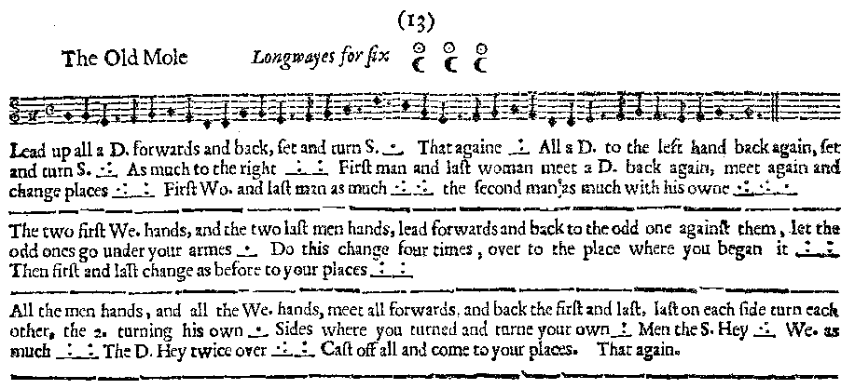

Transcription:

Lead up all a D. forwards and back, set and turn S. _.__ That againe _:__
All a D. to the left hand back again, set and turn S. _.:___ As much to the right _::___ First man and last woman meet a D. back again, meet again and change places _.:____:__ First Wo. and last man as much _.:____.:___ the second man as much with his owne _.:____.:____:__

The two first We. hands and the two last men hands, lead forwards and back to the odd one against them, let the odd ones go under your armes _.__ do this change four times, over to the place where you began is _:___:__
Then first and last change as before to your places _:___:__

All the men hands, and all the We. hands, meet all forwards and back the first and last, last on each side turn each other the 2. turning his owne _.__
Sides where you turned and turne your owne _:__ Men the S. Hey _.:__ We. as much _:___:__ The D. Hey twice over _.:____:__
Cast off all and come to your places. That again.

Redaction:

A1: Double forward and back; set and turn
Repeat.
Double to your own left and back; set and turn
Double to your own right and back; set and turn
Man 1 and Woman 3 double toward each other and back. Meet again and switch places.
Man 3 and Woman 1 double toward each other and back. Meet again and switch places.
Couple 2 double toward each other and back. Meet again and switch places.

A2: W1 and W2 join hands, M2 and M3 join hands. Both double forward to meet the odd one out, and back again. Go forward again with the odd ones out going under the arms of the two meeting them.
Do this three more times.
(Repeat the second half of A1 to reset the line:)
Man 1 and Woman 3 double toward each other and back. Meet again and switch places.
Man 3 and Woman 1 double toward each other and back. Meet again and switch places.
Couple 2 double toward each other and back. Meet again and switch places.

A3: Men take hands, Women take hands, and forward to meet the other line. Couples 1 and 3 double back (Couple 2 stand)..
M1 turn M3, W1 turn W3, and Couple 2 turn each other (simultaneous).
Side with the person you just turned.
Full turn your partner.
Men do full hey back to place.
Women do full hey back to place.
Double hey. Repeat double hey.
Cast off full back to place. Repeat the cast off.
Justification and Notes:

Line ends proper and reversed

Women forward to meet M1. Men forward to meet W3

Question: do the same two take hands and go forward each time, or do the people taking hands switch off as they go to the other side? i.e., is it always the original W1 and W2, or is it the people in the W1 and W2 places?
OR
Double forward the same two around the square - i.e., W1 and W2 first do the change with M1, then with W3 in her new spot, then M1 again, then W3 again to get back to start.

Assume side left and right.

Hey around both lines (grand right and left)

