Title: The New Exchange Shape: line
Dance #: 8 Type: standard
# Dancers: 3 Couples

Time Signature: 6/8
A Part: 8 measures, 16 beats, 4 times
B Part: No B part

Facsimile:
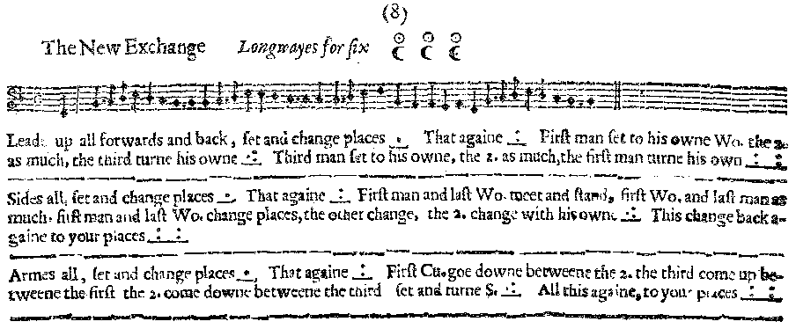

Transcription:

A1&A2: Lead up a D. forwards and back, set and change places _.__ That Again _:__
A3: First man set to his owne Wo. the 2. man as much, the third turn his owne _.:___
A4: Third man set to his owne, the 2. as much, the first man turn his owne _::___

A5&A6: Sides all, set and change places _.__ That Again _:__
A7: First man and last Wo. meet and stand, first Wo. and last man as much, first man and last Wo. change places, the other change, the 2. with his own _.:___
A8: This change back again to your places _::___

A9&A10: Armes all, set and change places _.__ That Again _:__
A11: First Cu. goe down between the 2. the third come up between the first and the 2. come down between the third set and turn S. _.:___
A12: All this againe, to your places _::___

Redaction:

Section 1
A1: Double forward and back, Set and turn
A2: Double forward and back, Set and turn
A3: M1 set to W1; M2 set to W2. C3 full turn.
A4: M3 set to W3; M2 set to W2. C1 full turn.

Section 2
A5: Sides Right, Set and turn
A6: Sides left, Set and turn
A7: M1 and W 3 meet; M3 and W1 meet;
M1 and W3 switch places; M3 and W1 switch places; C2 change with own.
A8: M1 and W 3 meet; M3 and W1 meet;
M1 and W3 switch places; M3 and W1 switch places; C2 change with own.

Section 3
A9: Arm right, set and turn
A10: Arm left, set and turn
A11: C1 move down between C2 as C2 moves up outside. Then C3 moves up between C1 as C1 moves down outside. Then C2 moves down between C3 as C3 moves up outside.
Set and turn
A12: Half shuttlecock same as above with C3 starting (who are now in the C1 position).
Set and turn
Justification and Notes:

Not sure how this works without people running into one another. One idea is to have Cs 1 and 3 meet behind C2 (outside the set). Also, we think that the couples meeting should happen at the same time, as well as the couples switching. Otherwise they won’t have enough time.

This is basically a ‘half shuttlecock’ to reverse the line.

