Title: Mage on a Cree Shape: Circle
Dance #: 20 Type: Standard
# Dancers: 8

Time Signature: 6/8
A Part: 8 measures, ? beats, ? times

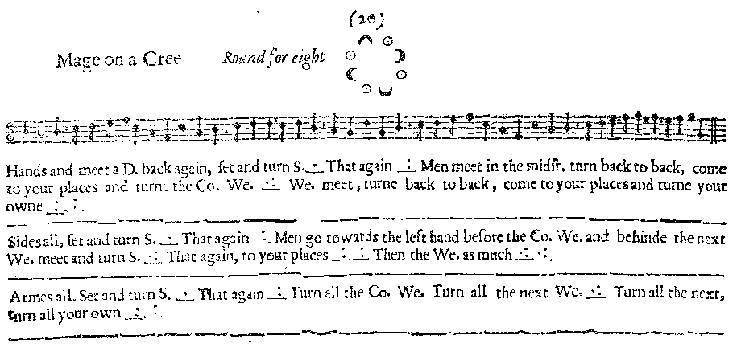
Facsimile:

Transcription:

Hands and meet a D. back again set and turn S. _.__ That again _:__
Men meet in the midst, turn back to back, come to you places and turn the Co. We. _.:__ We. meet, turn back to back, come to your places and turne your owne _:___:__

Sides all, set and turn S. _.__ That again _:__
Men go towards the left hand before the Co. We. and behind the next We. meet and turn S _.:__ that again, to your places _:___:__ Then the We. as much _.:____.:___

Armes all, set and turn S. _.__ That again _:__
Turn all the Co. We. Turn all the next We. _.:___ turn all the next, your own _:___:__

Redaction:

A1: Double in and out, set and turn partner. Repeat.
M to center, turn back to place. Turn your contrary woman.
W to center, turn back to place. Turn your partner.

A2: Sides right, set and turn partner. Sides left, set and turn partner.
Men cross in front of contrary Woman and behind the next Woman. Meet in center and turn single.
Men cross in front of next Woman and behind partner. Turn single.
Women cross in front of contrary Man and behind the next Man. Meet in center and turn single.
Women cross in front of next Man and behind partner. Turn single.

A3: Arms right, set and turn partner. Arms left, set and turn partner.
Men turn the contrary woman. Turn the next woman, then the next, then your partner.
Justification and Notes:

Turns here will actually be 1-1/2 turns so that the men will face their next partner.

