Title: Hit and Misse Shape: Square
Dance #: 18 Type: Standard
# Dancers: 4

Time Signature: 6/8
A Part: 4 measures, 8 beats, 2 times
B Part: 4 measures, 8 beats, 2 times
C Part: 4 measures, 8 beats, 2 times

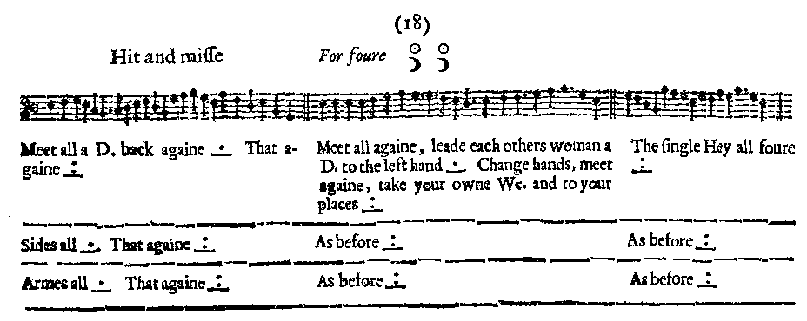
Facsimile:

Transcription:

Meet all a D. back again _.__ That againe _:__
Meet all again, lead each others woman a D. to the left hand _.__ Change hands, meet again, take your owne We. and to your places _:__
The single Hey all foure _:__

Sides all _.__ That againe _:__
As before _:__
As before _:__

Armes all _.__ That againe _:__
As before _:__
As before _:__

Redaction:

A1: Double forward to meet the others, and then back. Twice
B1: Double forward. Take corner and go a double out. Turn around and double back. Take partner and double out to starting position.
C1: Hey for 4.

A2: Side right with partner, Side left with partner.
B2: Double forward. Take corner and go a double out. Turn around and double back. Take partner and double out to starting position.
C2: Hey for 4.

A3: Arm right with partner, Arm left with partner.
B3: Double forward. Take corner and go a double out. Turn around and double back. Take partner and double out to starting position.
C3: Hey for 4.
Justification and Notes:

We think the drawing of the arrangement of the couples is wrong, and they should be set up with couples facing one another in a square (as for Argeers). Otherwise the B part doesn’t work.

