Title: Grimstock Shape: Line
Dance #: 14 Type: Standard
# Dancers: 6

Time Signature: 6/8
A Part: 8 measures, 16 beats, 2 times?
B part: 4 measures, 8 beats, 2 times?

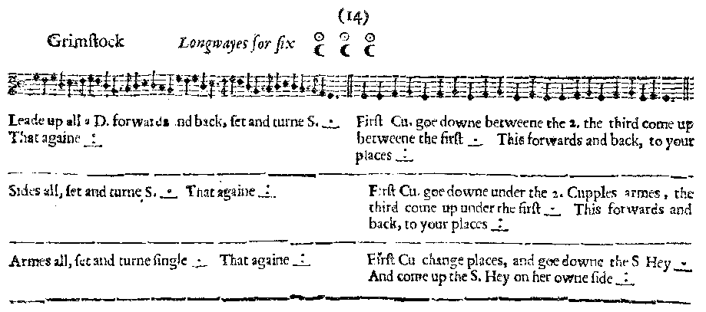
Facsimile:

Transcription:

Leade up all a D. forwards and back, set and turne S. _.__ That againe _:__
First Cu. goe downe between the 2. the third come up between the first _.__
This forwards and back to your places _:__

Sides all, set and turne S. _.__ That againe _:__
First Cu. goe downe under the 2. Cupples armes, the third come up under the first _.__ This forwards and back to your places _:__

Armes all, set and turne S. _.__ That againe _:__
First Cu change places, and goe downe the S Hey _._ And come up the S. Hey on her owne side _:__

Redaction:

A1: Forward and back, set and turn
Repeat
B1: Shuttlecocks (C1 going between C2) until back to place.

A2: Side left, set and turn
Side right, set and turn
B2: Arches all (C1 going under C2) until back to place

A3: Arms right, set and turn
Arms left, set and turn
B3: C1 switch places and begin a hey with their new line. When C1 is in C3 position, switch places again and hey back up their own line.

Justification and Notes:

