Title: Greenwood Shape: Line
Dance #: 16 Type: Improper
# Dancers: 6

Time Signature: 6/8
A Part: 8 measues, 16 counts

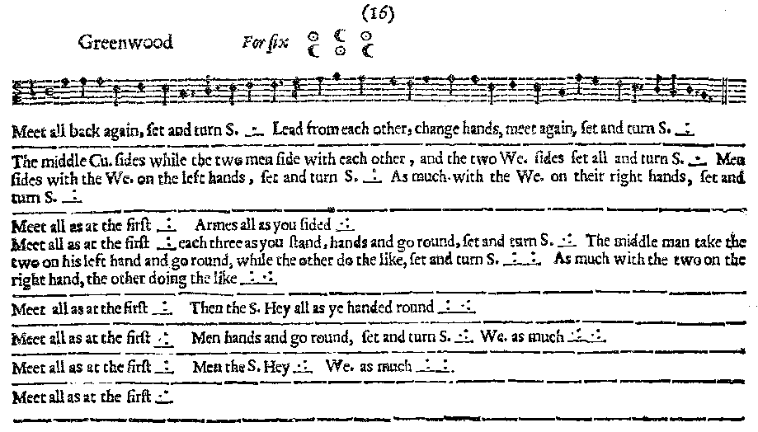
Facsimile:

Transcription:

Meet all back again, set and turn S. _.__ Lead from each other, change hands, meet again, set and turn S. _:__
________________________________________
The middle Cu. sides while the two men side with each other, and the two We. sides set all and turn S. _.__ Men sides with the We. on the left hands, set and turn S. _:__ As much with the We. on their right hands, set and turn S. _:__
________________________________________
Meet all as at the first _:__ Armes all as you sided _.:__
Meet all as at the first _:__ each three as you stand, hands and go round, set and turn S. _.:___ The middle man take the two on his left hand and go round, while the other do the like, set and turn S. _:___:__ As much with the two on the right hand, the other doing the like _:_.:_
________________________________________
Meet all as at the first _:__ Then the S. Hey all as ye handed round _:_.:_
________________________________________
Meet all as at the first _:__ Men hands and go round, set and turn S. _.:_ We. as much. _.:_.:_
________________________________________
Meet all as at the first _:__ Men the S. Hey _.:_ We. as much _:_:_
________________________________________
Meet all as at the first _:__

Redaction:

Double forward (toward the other line), double back
Set and turn.
Face out and double away from the set.
Face in again and double back to place.
Set and turn.

Middle couple side to the left, while the other two women side left and the other two men side left.
Set and turn
Men side right with the woman on the left
Set and turn
Men side left with the woman on the right
Set and turn

Meet all as the first

Middle couple arm right, while the other two women arm rightand the other two men arm right.
Set and turn
Men arm left with the woman on the left
Set and turn
Men arm right with the woman on the right
Set and turn

Meet all as the first

Each line take hands and circle for eight.
Set and turn
The middle man take hands with the couple on his left and circle for eight. Meanwhile the rest circle for eight.
Set and turn
The middle man take hands with the couple on his right and circle for eight. Meanwhile the rest circle for eight.
(Set and turn)

Meet all as the first

Justification and Notes:

Starts out each line facing the other line.

Later, when it says “meet all as the first” it means
everything up to this point.

The Set and turn here is not in the MS, but it’s needed if the pattern is to hold.

Each line do a single hey simultaneously.
(Set and turn)
The middle man does a single hey with the couple on his left. Meanwhile the rest single hey.
(Set and turn)
The middle man does a single hey with the couple on his right. Meanwhile the rest single hey.
(Set and turn)

Meet all as the first

Men take hands and circle for eight.
All set and turn
Women take hands and circle for eight.
All set and turn

Meet all as the first

Men single hey
(All set and turn)
Women single hey
(All set and turn)

Meet all as the first

Again, the sets and turns are not in the MS here, include to maintain the pattern? Or will there be enough time because of the heys?

Assume that the groups circle around the person in the center?

Again, the sets and turns are not in the MS here, include to maintain the pattern? Or will there be enough time because of the heys?

