Title: Confesse Shape: Altered line
Dance #: 19 Type: Standard
# Dancers: 2 Men, 4 Women

Time Signature:
A Part: 4 measures, 8 beats, 2 times
B Part: 8 measures, 16 beats, ? times

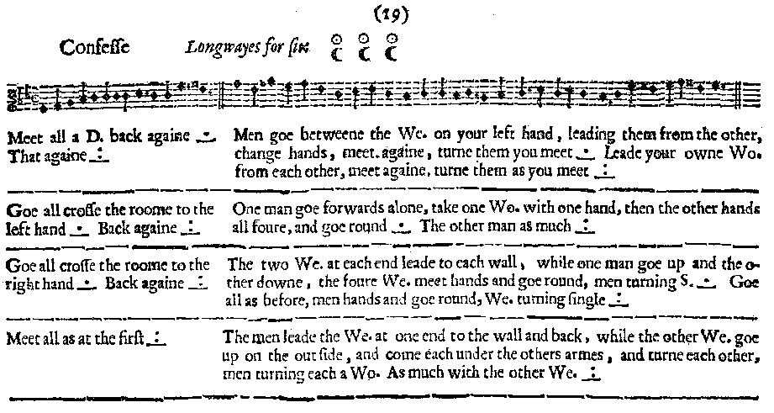
Facsimile:

Not correct (from a later edition). Should be:
   
   

Transcription:

Meet all a D. back again _._ That again.
Men goe between the We. on your left hand, leading them from the other, change hands, meet againe, turn them you meet _._ Leade your owne Wo. from each other, meet again, turn them as you meet _:_

Goe all cross the roome to the left hand _._ Back again _:_
One man goe forwards alone, take one Wo. with one hand, then the other hands all four, and goe round _._ The other man as much _:_

Goe all cross the roome to the right hand _._ Back again _:_
The two We. at each end leade to each wall, while one man goe up and the other downe, the four We. meet hands and goe round, men turning S. _._ Goe all as before, men hands and goe round, We. turning single _:_

Meet all all as at the first _:_
The men leade the We. at one end to the wall and back, while the other We. goe up on the outside, and come each under the others armes, and turne each other, men turning each a Wo. As much with the other We. _:_

Redaction:

A1: Each line Double forward to meet the other line, and then back. Twice
B1: Each man go between the two women on his left. Lead them away from the set a Double. Turn around and Double back. Full turn with the person you meet.
Each man lead out the two women in his own line. Lead them away from the set a Double. Turn around and Double back. Full turn with the person you meet.

A2: Bo peep slide left and back.
B2: Man 1 take his “partner” out of the set with one hand. The other four take hands and go round.
Man 1 take his “partner” out of the set with one hand. The other four take hands and go round.

A3: Bo peep slide right and back
B3: W1 and W3 double out, while W2 and W4 do the same. M1 doubles up, M2 doubles down. All meet back again. Women join hands and circle around. Men turn in place.
W1 and W3 double out, while W2 and W4 do the same. M1 doubles up, M2 doubles down. All meet back again. Men join hands and circle around. Women turn in place.

A4: Each line Double forward to meet the other line, and then back. Twice.
B4: M1 lead W1 away from the set to the wall and back. M2 lead W2 to the other wall and back. W3 and W4 cast off, go up the set, go under the arms of the other couples, and back to place. Full turn - M1 with W1, M2 with W2, and W3 with W4.
M1 lead W3 away from the set to the wall and back. M2 lead W4 to the other wall and back. W1 and W2 cast off, go down the set, go under the arms of the other couples, and back to place. Full turn - M1 with W3, M2 with W4, and W1 with W2.
Justification and Notes:

Men turn men and women turn women

Men turn men and women turn women

(Not sure what this means)
Unclear from MS whether couple should go into the set and the other four circle around them, or whether couple should exit the set (and how far.)
Because it says “One man go forward alone, take one woman,” it’s possible that the man could choose which woman he wanted to remove from the set, and the other 4 had to adjust.

Several options:
(1) There is a typo, and each subset should actually be walking away from the set (women up and down, and men out). In this case the first half of each B part is exactly the same each time.
(2) The 2nd time, everyone should go in the direction opposite the one they went previously. (If W1 and W3 went to the left wall the 1st time, they should go to the right wall the 2nd time. M1 should go down and M2 should go up the 2nd time.)

