Title: Bobbing Joe Shape: Line
Dance #: 7 Type: New Progression
# Dancers: Couples, as many as will

Time Signature: 6/8
A Part: 4 measures, with repeats
B Part: 4 measures, with repeats (repeat as many times as there are people in each set)

Facsimile:
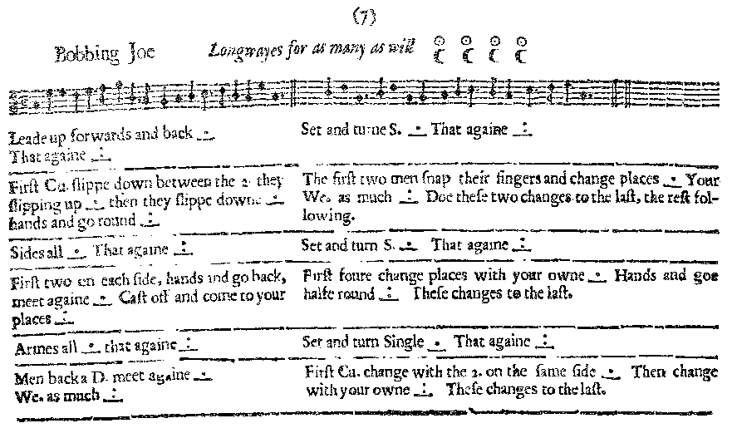
Transcription:

Bobbing Joe Longways for as many as will

A1: Leade up forwards and back _.__ That again _:__
B1: Set and turn S. _.__ That again _:__

A2: First Cu. slippe down between the 2 they slipping up _.__ then they slippe downe_.__ hands and go round _:__
B2: The first two men snap their fingers and change places_.__ Your We. as much _:__ Doe these two changes to the last, the rest following.

A3: Sides all _.__ That againe _:__
B3: Set and turn S. _.__ That againe _:__

A4: First two on each side, hands and go back, meet again_.__ Cast off and come to your places _:__
B4: First four change places with your owne _.__ Hands and goe halfe round _:__ These changes to the last.

A5: Armes all _.__ That againe _:__
B5: Set and turn S. _.__ That againe _:__

A6: Men back a D. meet again _.__ We. as much _:__
B6: First Cu. change with the 2. on the same side _.__ Then change with your owne _:__ These changes to the last.

Redaction:

A1: Double forward and back, twice
B1: Set and turn, twice

A2: C1 slip down between C2 as C2 slips up the set.
C2 slip down between C1 as C1 slips up the set
C1 and C2 turn full circle w/ hands.
B2: Man 1 and Man 2 snap fingers and change places.
Woman 1 and Woman 2 snap fingers and change places.
Couple 1 repeat the snaps and changes with couple 3, then couple 4 until line is restored.

A3: Side right, Side left
B3: Set and turn, twice

A4: M1 and M2 take hands and double back and forward again while W1 and W2 do the same.
Cast off on each side with your line following, back to place.
B4: C1 and C2 change places with your partners. Take hands and circle half round.
Couple 1 repeat the change and half circle with couple 3, then couple 4 until line is restored.

A5: Arm right and left
B5: Set and Turn, twice

A6: Men back a double, then forward a double.
Then Women back a double, forward a double.
B6: M1 and M2 switch as W1 and W2 switch.
1st two couples change with own.
Couple 1 do these switches with couple 3, then couple 4 until line is restored.
Justification and Notes:

All couples should follow down as they reach the top ot the set.

To switch places of C1 and C2

