Title: The Beggar Boy Shape: Line
Dance #: 5 Type: Standard
# Dancers: 3 Couples

Time Signature: 6/8
A Part: 4 measuers, 8 beats
B Part: 8 measuers, 16 beats
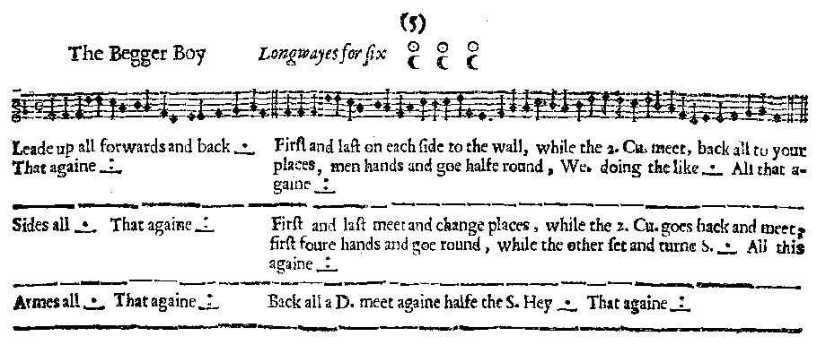
Facsimile:

Transcription:

The Begger Boy Longways for six

A1: Lead up a D. forwards and back, set and turn single _.__ That Again _:__

B1: First and last on each side to the wall, while the 2. Cu meet, back all to your places, men hands and goe halfe round, We. doing the like _.__ All that Again _:__

A2: Sides all, set and turn S. _.__ That Again _:__

B2: First and last meet and change places, while the 2. Cu. goes back and meet. First foure hands and goe round, while the other set and turn S. _.__ All this again _:__

A3: Armes all, set and turn S. _.__ That Again _:__

B3: Back all a D. meet again half the S. Hey _.__ That again _:__

Redaction:

A1: Double forward, Double back. Repeat

B1: (Face partners.)
Couple 1 and Couple 3 Double back while couple 2 Double forward to meet.
Couple 1 and Couple 3 Double forward to meet while couple 2 Double back.
Men do 1/2 circle together while women do 1/2 circle together (to reverse the line).
Repeat all (resets line).

A2: Side right, Side left.
Repeat

B2: (Face partners.)
Second couple back a Double, then forward a Double. Meanwhile Couples 1 and 3 meet in the middle and switch places.
Positions 1 and 2 all take hands and full circle while Position 3 set and turn.
Repeat all (resets line).

A3: Arm right, Arm left
Repeat

B3: (Face partners.)
All back a double, forward a double.
1/2 hay on each side (to reverse the line)
Repeat all (resets line).

Justification and Notes:

C1 & C3 meet while C2 going back, into opposite place as C2 comes forward. Line should still be proper after switch.

